FIGHTING FIRE WITH FIRE
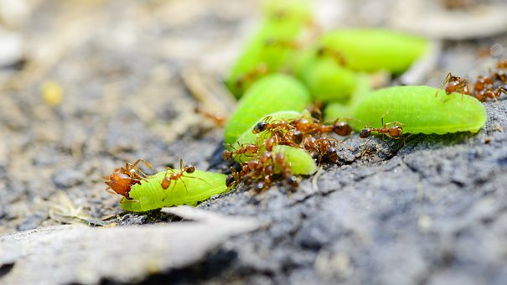
By niamh williams DATE august 2018

Image from pixabay

Answer the following questions in full sentences:
- What is this news story about?
Scientists investigated how a species of ant is able to survive being sprayed by the lethal venom of another species of ant.

- Explain why the investigators used a group of ants with nail polish painted over their abdomen.
As a control group, so they could determine whether or not the formic acid was having the effect (as this was excreted from the abdomen).

- Describe the results of the investigation.
98% of the ants that could produce formic acid survived while only 48% of the ants that could not produce formic acid survived.

- Suggest the pH range that the fire ant venom would fall into.
Alkaline (pH 8-14)

- Write down the meanings of any words in bold in the article.
Tactics – strategies or actions planned to achieve a certain goal
Lethal – can cause death
Colonies – populations or communities of organisms living close together
Displace – take over the place or position of something else
Abdomens – the part of the body between the thorax and pelvis, in insects the segmented part of the body behind the thorax

